**Angular Task: Version 1**

Task: (Topics: Basics ,Components ,Data Binding , Data Objects ,Angular Forms , Structural Directives)

Create an angular application to manage the product details with the following specifications.

1. Create a component named product
2. Add the component ref in app component.html
3. Create a class named product as follows

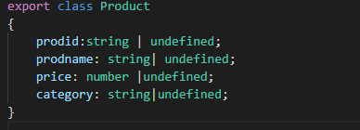

1. Create a product array and category array in product component as follows

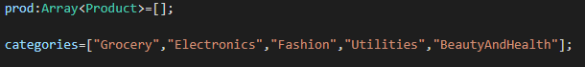

1. Use Angular Forms (TDF) to create the Product Screen including validations.
2. Category must be a drop down list and should have the values from categories array.
3. Validations are as Follows
   1. No fields should left blank
   2. Price must be number
   3. Category must be selected.
4. The Product Form should Look as shown

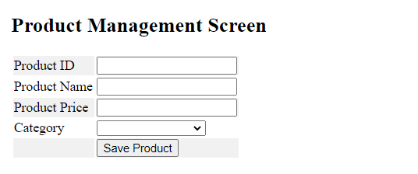

1. When user clicks on Save Product , The data should save in the product array created and should displayed in a grid format as follows.

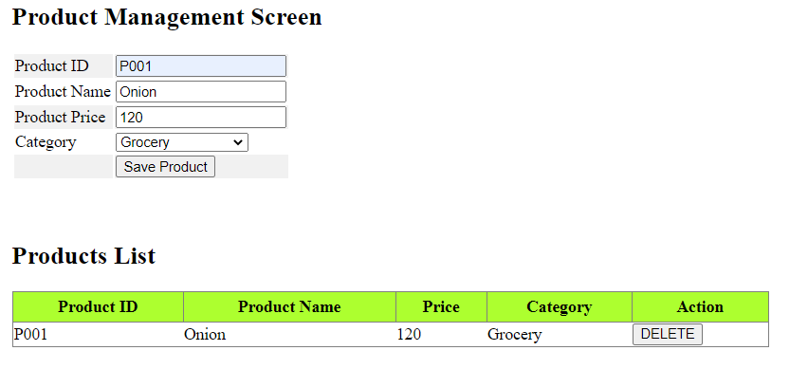

1. The grid should have DELETE button.
2. When user clicks the delete button , the current row should be deleted from the array.

Sample Screens as Follows.

Screen1 :

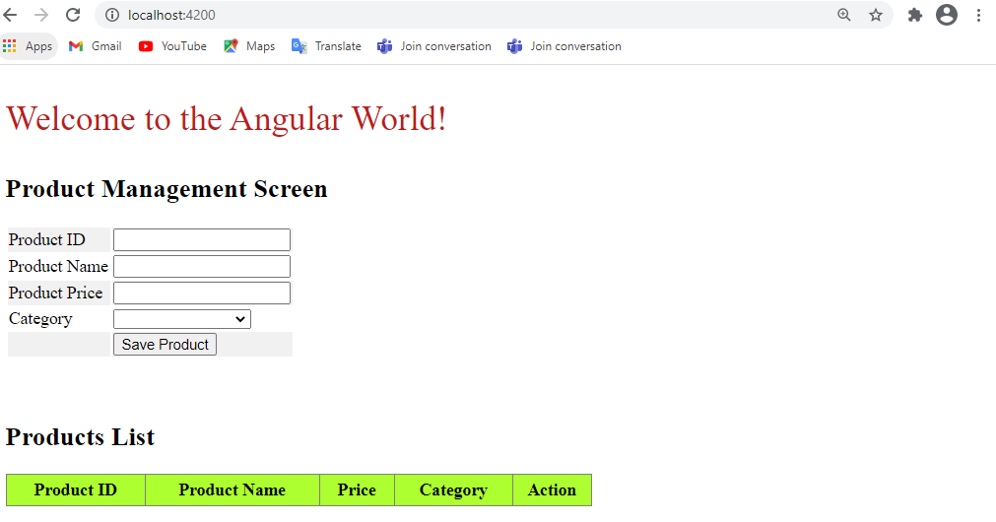

Screen 2:

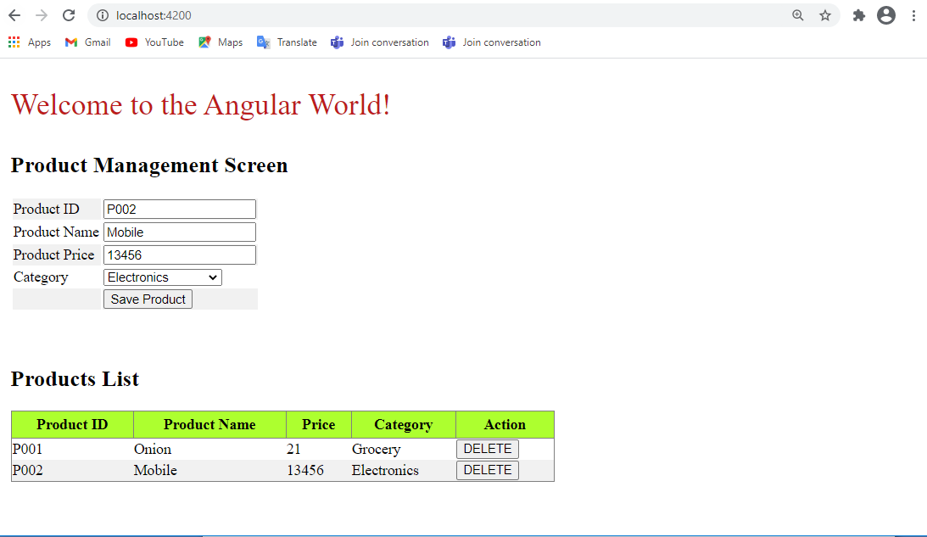

Screen 3:

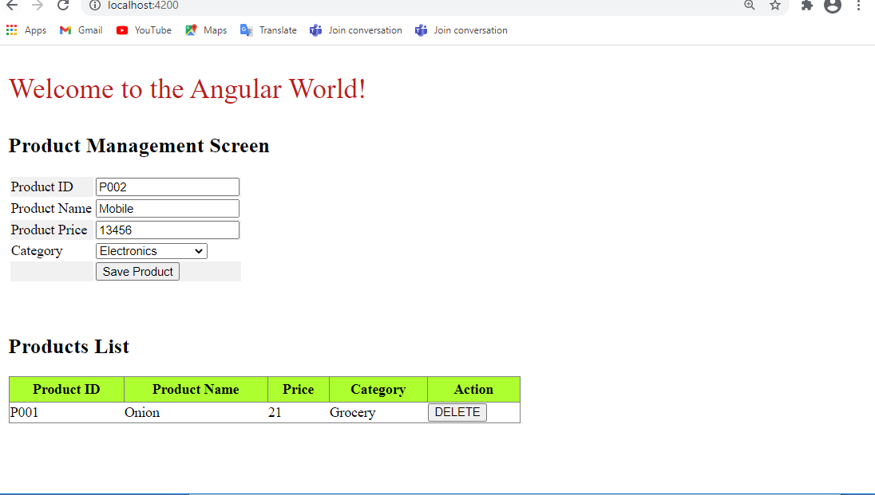

After delete.